Week beg 2nd January 2022
there/their/they’re
hear/here
quiet/quite
see/sea
bear/bare
one/won
sun/son
too/to/two
be/bee
blue/blew
knight/night
Wednesday – Can you draw a picture to go with each homophone?
there/their/they’re
hear/here
quiet/quite
see/sea
bear/bare
one/won
sun/son
too/to/two
be/bee
blue/blew
knight/night

asdasd
Spelling Rule- YEAR 2

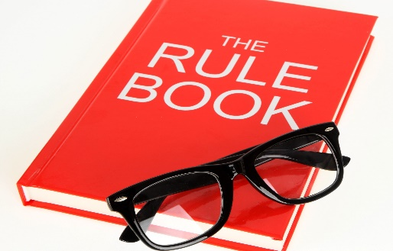

Homophones

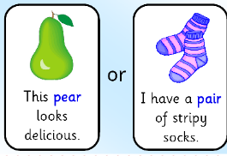

Tuesday- What are homophones?
____________________________________________________________________________________________________________________________________

Once you’ve written an answer, go and explain to your Mum or Dad.
Thursday – Can you write a sentence with both words in? e.g. ‘I can see the sea’
______________________________________________________________________________________________________________
______________________________________________________________________________________________________________
______________________________________________________________________________________________________________
______________________________________________________________________________________________________________
______________________________________________________________________________________________________________
______________________________________________________________________________________________________________
______________________________________________________________________________________________________________
______________________________________________________________________________________________________________
______________________________________________________________________________________________________________
______________________________________________________________________________________________________________

1

Week beg 2nd January 2022
break/brake
fair/fare
great/grate
groan/grown
here/ hear
heel/heal/he’ll
not/knot
male/mail
main/main
meat/meet
peace/piece
plain/plane
Wednesday – Can you draw a picture to go with each homophone?
break/brake
fair/fare
great/grate
groan/grown
here/ hear
heel/heal/he’ll
not/knot
male/mail
main/main
meat/meet
peace/piece
plain/plane

asdasd
Spelling Rule-YEAR 3

Homophones

Tuesday- What are homophones?
________________________________________________________________________________________________________________________

What are homonyms?
________________________________________________________________________________________________________________________
Once you’ve written an answer, go and explain to your Mum or Dad.

Thursday – Can you write a sentence with both words in? e.g. ‘I can see the sea’
______________________________________________________________________________________________________________
______________________________________________________________________________________________________________
______________________________________________________________________________________________________________
______________________________________________________________________________________________________________
______________________________________________________________________________________________________________
______________________________________________________________________________________________________________
______________________________________________________________________________________________________________
______________________________________________________________________________________________________________
______________________________________________________________________________________________________________
______________________________________________________________________________________________________________

1

