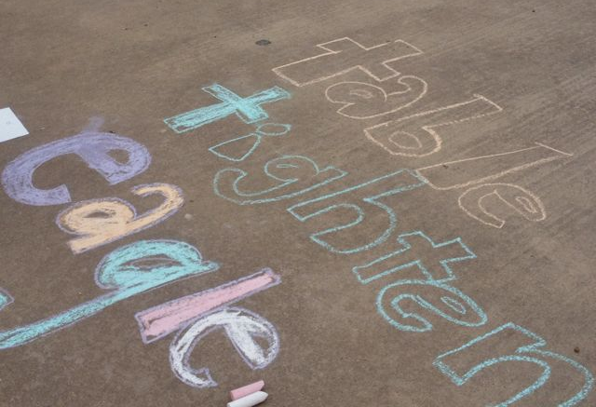
Wednesday – Write your spellings outside using chalk.

Week beg 11th July 2022
sure
measure
treasure
enclosure
creature
picture
nature
feature
asdasd
Spelling Rule- YEAR 2

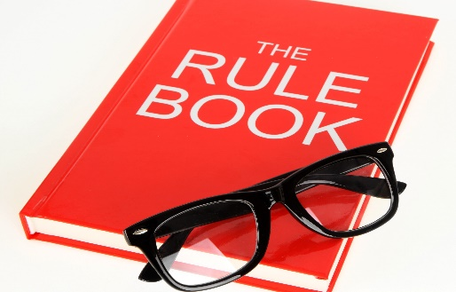

ure

zhure sound

Tuesday- Write the words but use a different colour for vowels.
sure________________________________________
measure_____________________________________
treasure_____________________________________
enclosure____________________________________
creature_____________________________________
picture______________________________________
nature______________________________________
feature_______________________________________

________________________________

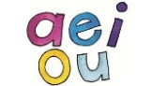
Thursday – Write your spellings using only capital letters.
sure________________________________________
measure_____________________________________
treasure_____________________________________
enclosure____________________________________
creature_____________________________________
picture______________________________________
nature______________________________________
feature_______________________________________

1

asdasd
Week beg 11th July 2022
leisure
unsure
pleasure
furniture
adventure
moisture
fracture

Spelling Rule-YEAR 3

Wednesday – Write your spellings outside using chalk.

ure

zhure sound

Tuesday- Write the words but use a different colour for vowels.
leisure_____________________________________________
unsure_____________________________________________
pleasure___________________________________________
furniture___________________________________________
adventure__________________________________________
moisture___________________________________________
fracture___________________________________________

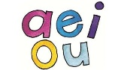
Thursday – Write your spellings using only capital letters.
leisure_____________________________________________
unsure_____________________________________________
pleasure___________________________________________
furniture___________________________________________
adventure__________________________________________
moisture___________________________________________
fracture___________________________________________
television___________________________________________________________________________________

1

