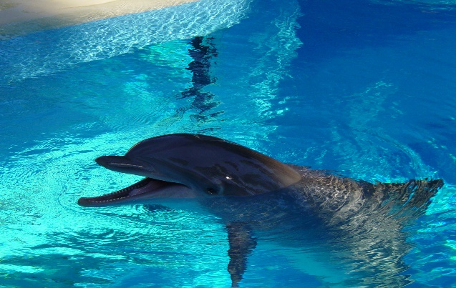
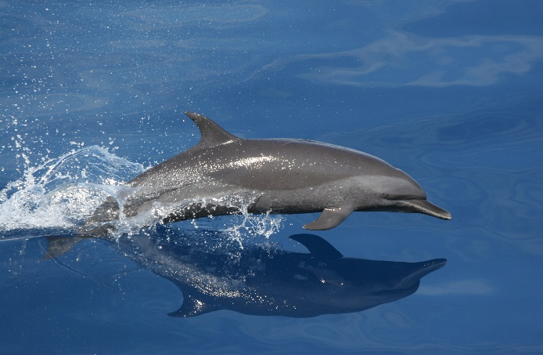
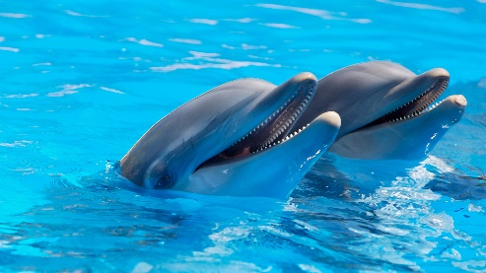

DOLPHINS
Dolphins are very intelligent animals.
Here are some facts about these wonderful marine mammals!
- There are over 42 species of dolphin!
Here are some now: striped dolphin, spotted, pilot, orca, hectors, spinner, bottle nose, short nose, long nose, river, maimi, commersons, common, dusky… and so much more.
- Their pregnancy lasts between 9 months-16 months.
- Dolphins eat crustaceans, squid and fish.
- Did you know that a Killer Whale/ Orca is a dolphin!?
- Dolphins have small wavy teeth to help cut their food.
- Dolphins each have a unique curved fin!
- They have 2 stomachs!
- Dolphins don`t drink!
- Their scientific name is dolphinus
- Dolphins don`t swallow!

