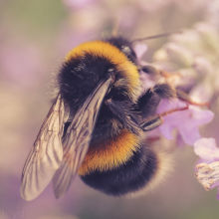
BUMBLEBEE FACTS!
Bumblebees are very interesting insects because there are over 250 bee species are considered bumblebees. Now I am going to tell you Bumblebees are in trouble so that is why we should plant just a few plants. Did you also know that there are 24 different types of bee species in the UK, Bumble Bees are very important pollinators of wild flowers and agricultural crops. Also the Early bumble bees are 1-1.4 cm now isn’t that fascinating .To carry on to that fact the early bumble bee lives for only twenty eight days. Actually most bumble bees are social and live in nests of 50-400 bumble bees and their ID: is a round and furry appearance with a familiar beep buzz (top tip for ID start with the tail colour first) .Did you know there are over 270 different species of bees in the UK (not just bumble bees). The most likely bumble bees to see in the UK are common carder bee and the early bee. Now I am going to tell you about the bee stages of an bee it starts of as an egg then it’s a larva then a pupa then a bee isn’t that is so cool .Now I am going to tell you that a bee dies after they stings you . Now an, other fact is that the Queen bees only hibernates for 9 months. Top tip: if you have a bee hive when you place it do not move the hive because your bees not find the hive and they will die!



