Lime and Elder
Carols by Candlelight Words 

Come with us

(Solo)
Come with us to distant lands and places
Hear the words of prophets long ago
Watch with us and you may see the faces
Of those whose story we all know

(Solo)
Come with us and hear the angels singing
See the stars and find the stable bare
Look inside and as the bells are ringing
You may find your treasure there

(Solo)
Come with us to distant lands and places
Hear the words of prophets long ago
Watch with us and you may see the faces
Of those whose story we all know

(soloists group)
Come with us and hear the angels singing
See the stars and find the stable bare
Look inside and as the bells are ringing
You may find your treasure there

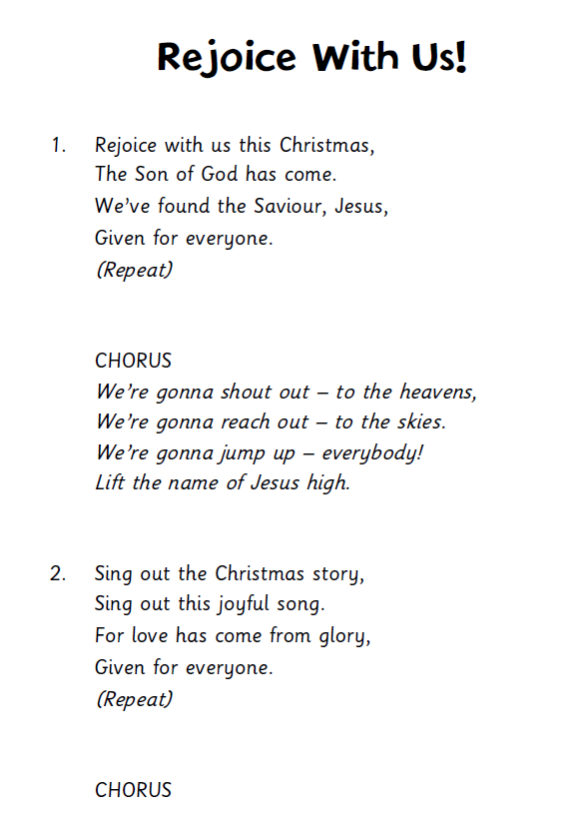

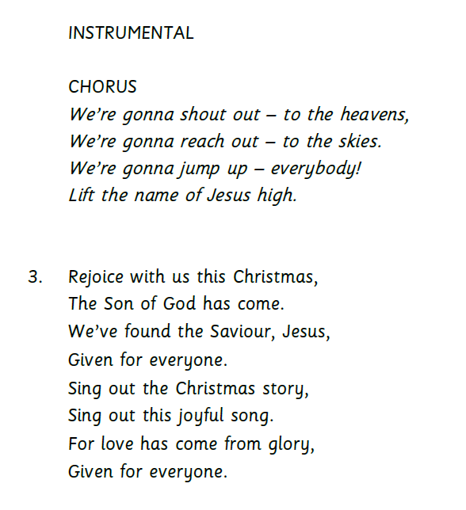

Once in Royal David’s City

(Solo)
Once in Royal David’s city,
Stood a lowly cattle shed,
Where a mother laid her Baby,
In a manger for His bed:
Mary was that mother mild,
Jesus Christ, her little Child.

He came down to earth from heaven,
Who is God and Lord of all,
And His shelter was a stable,
And His cradle was a stall:
With the poor, and mean, and lowly,
Lived on earth our Saviour holy.

For He is our childhood's pattern;
Day by day, like us, He grew;
He was little, weak, and helpless,
Tears and smiles, like us He knew;
And He cares when we are sad,
And he shares when we are glad.

And our eyes at last shall see Him,
Through His own redeeming love;
For that Child so dear and gentle,
Is our Lord in heaven above:
And He leads His children on,
To the place where He is gone.

Mary and the angel

(Solo)
Very early in the morning
Softly at the break of day
Mary sits dreaming
Then she looks and sees
There’s an angel
And hears him say.

Mary listen
You’re the one
God chose you to be the mother here of his son

(Solo)
Mary bows her head in worship
As she wonders at this birth
How can this be that God has chosen me?
For this purpose
Down here on earth?

Mary listen
Only trust
This child is to show to all the world God is with us
God is with us

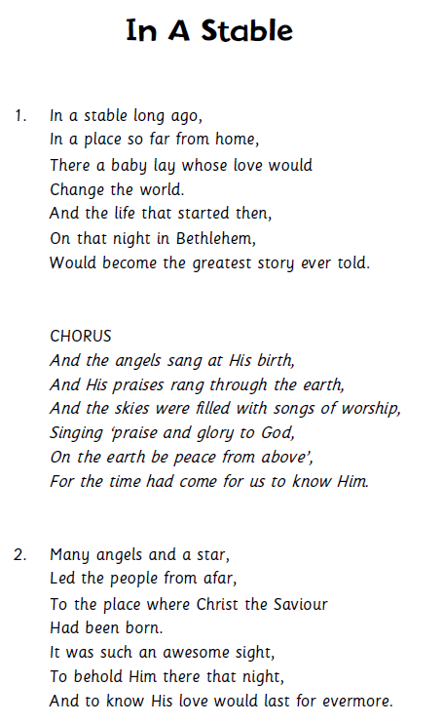

(Solo)

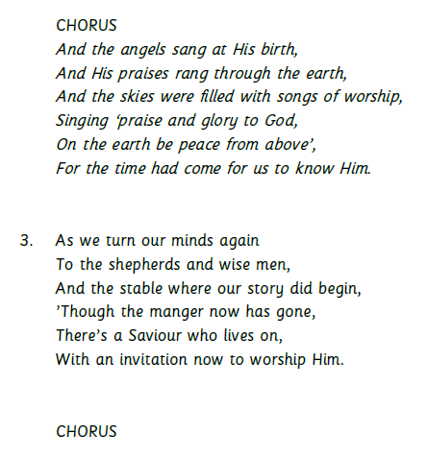

Away in a Manger

(Solo)
Away in a manger,
No crib for His bed
The little Lord Jesus
Lay down His sweet head
The stars in the bright sky
Looked down where He lay
The little Lord Jesus
Asleep on the hay

The cattle are lowing
The Baby awakes
But little Lord Jesus
No crying He makes
I love Thee, Lord Jesus
Look down from the sky
And stay by my side,
Until morning is nigh.
Be near me, Lord Jesus,
I ask Thee to stay
Close by me forever
And love me I pray
Bless all the dear children
In Thy tender care
And fit us for heaven
To live with Thee there

One bright star

(Solo)
Suddenly my eyes were dazzled
I could hardly see at all.
The music in my ears:
Such a heav’nly call!
As I stood I felt a wonder
That I’ve never felt before
Although my heart was full
I just wanted more

(duet)
And then as we shepherds listened,
We heard angels sing on high:
Our saviour has been born!
Praises filled the sky!
So the celebration started as the life of Christ began
The King of love was born.
For the sake of man.

One bright star shone out that night.
Bringing hope to all mankind.
One bright star shone out to say: He is born!
One bright star that promised peace
And no more fighting
One bright star
Just one bright star
Just one bright star to take us there:

Then we knew just what to do,
So we ran to find the child,
To seek the new-born King,
Welcome Him in style.
And we gave our minds and hearts
On this very special night
To baby Jesus
Son of Man and God’s pure light.

One bright star shone out that night.
Bringing hope to all mankind.
One bright star shone out to say: He is born!
One bright star that promised peace
And no more fighting
One bright star (one bright star)
Just one bright star (one bright star)
Just one bright star to take us there:
One bright star x4

We Three Kings

We three kings of Orient are,
bearing gifts we traverse afar.
Field and fountain, moor and mountain,
Following yonder star
O Star of wonder, star of night
Star with royal beauty bright
Westward leading, still proceeding
Guide us to thy Perfect Light.

(Solo)
Born a King on Bethlehem's plain
Gold I bring to crown Him again
King forever, ceasing never
Over us all to reign
O Star of wonder, star of night
Star with royal beauty bright
Westward leading, still proceeding
Guide us to Thy perfect light.

(Duet)
Frankincense to offer have I
Incense owns a Deity nigh
Prayer and praising, all men raising
Worship Him, God most high
O Star of wonder, star of night
Star with royal beauty bright
Westward leading, still proceeding
Guide us to Thy perfect light.

(Duet)
Myrrh is mine, its bitter perfume
Breathes of life of gathering gloom
Sorrowing, sighing, bleeding, dying
Sealed in the stone-cold tomb
O Star of wonder, star of night
Star with royal beauty bright
Westward leading, still proceeding
Guide us to Thy perfect light.

Glorious now behold Him arise
King and God and Sacrifice
Alleluia, Alleluia
Earth to heav'n replies
O Star of wonder, star of night
Star with royal beauty bright
Westward leading, still proceeding
Guide us to Thy perfect light

Silent Night

(Solo)
Silent night, holy night
All is calm, all is bright,
Round yon virgin mother and child
Holy infant so tender and mild
Sleep in heavenly peace.
Sleep in heavenly peace.

Silent night, Holy night
Son of God, love's pure light
Radiant beams from thy holy face
With the dawn of redeeming grace,
Jesus, Lord at thy birth
Jesus, Lord at thy birth.

Silent night, Holy night
Shepherds quake, at the sight
Glories stream from heaven afar
Heavenly, hosts sing Hallelujah.
Christ the Saviour is born,
Christ the Saviour is born.

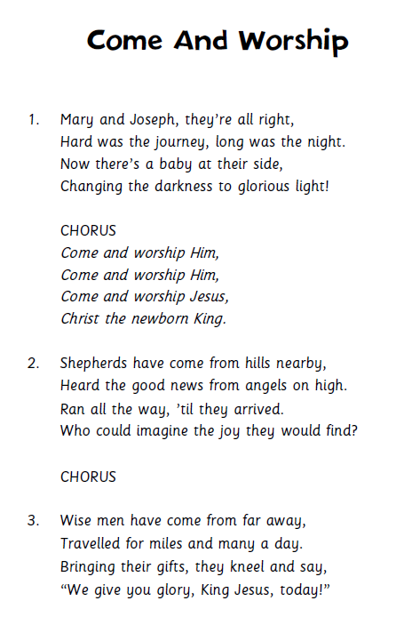

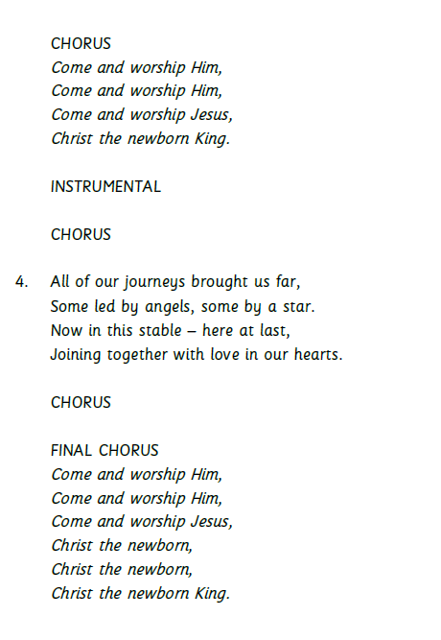

O HOLY NIGHT

O Holy Night! The stars are brightly shining,
It is the night of the dear Saviour's birth.
Long lay the world in sin and error pining.
Till He appeared and the Spirit felt its worth.
A thrill of hope the weary world rejoices,
For yonder breaks a new and glorious morn.
Fall on your knees! Oh, hear the angel voices!
O night divine, oh night when Christ was born;
Oh night divine, oh night, oh night divine.

Truly He taught us to love one another,
His law is love and His gospel is peace.
Chains he shall break, for the slave is our brother.
And in his name all oppression shall cease.
Sweet hymns of joy in grateful chorus raise we,
Let all within us, praise His holy name.
Christ is the Lord! Oh praise his name forever,
O night divine, oh night when Christ was born;
Oh night divine, oh night, oh night divine.

