PTA AGM meeting minutes - 08/10/2020
Attendees: Mrs Ayres, Rob Alesbury, James Lewis, Silvia Blake, Caz Young, Kate Palgrave, Helen and Michael Mcilroy, Michelle Elton, Emma and Jordan, Nicky, Clare Walters, Emily Messenger, Felicity Wevill, Lou, Laura West, Hollie, Tammy Knight

- Confirmation of roles for 2019-2020
- Year reps
  - R – Hollie Fleming
  - 1 – James Lewis
  - 2 – Katy Taylor
  - 3 – Felicity Wevill
  - 4 – Nicky Bannam
  - 5 – TBC. No year 5 parents present
  - 6 – Elliot
- The following roles were agreed and seconded with no objections.
  - Committee coordinator – Caz Young
  - Treasurer – Silvia Blake
  - Secretary - Rob Alesbury

- Finances:
Silvia provided a finance update:
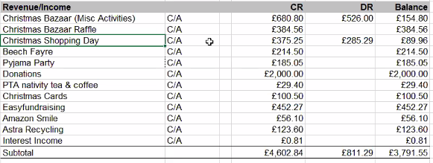
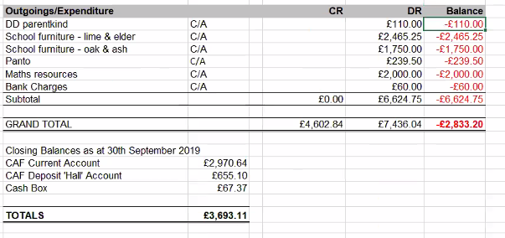
- £2000 contingency for IT requirements
  - Server cost coming up next year

- Current funding needs

- PTA usually supports (~£750-£1000):
  - Pantomime and Christmas Crackers (£500) Could split between voluntary parent contribution.
  - Trophies for Quiz (£40-£50)
  - Fruit for Sports Day (£70-80)
  - End of year staff lunch (£100)
  - Pupil council (£50)

- Suggested projects for fundraising
  - Apps for iPads – We have done a book drive for the last 2 years for teachers. Could we do an app drive? Mathletics?
  - Music room
    - Painting music room – Community day
    - Furniture
    - Music scheme of work
  - Outdoor learning area – James will look into plans and costs.
  - New artificial grass for trim trail

- Fund raising ideas

- Waitrose or Tesco grants – Lou will provide
- Non uniform days
- Christmas raffle – Need somebody to co-ordinate.
- Year 6 calendar – Photography
- Apprentice – Online shop
  - As a charity we may be able to set up an online shop with secure payment – Lou offered to investigate this.
  - Kids could set up the shop
- Monthly draw
- Gofundme
- Non uniform days
- Break the rules day
- Children cannot take cash into school but parents could put money into a collection box.
- Reconvene after half term to talk Christmas
- Thursday 5th November. 8pm

- Actions

- Newsletter update for Astra Recycling – Caz

