Milestone Data 2023-2024- Perspective
Early Years Foundation Stage Profile- Year R

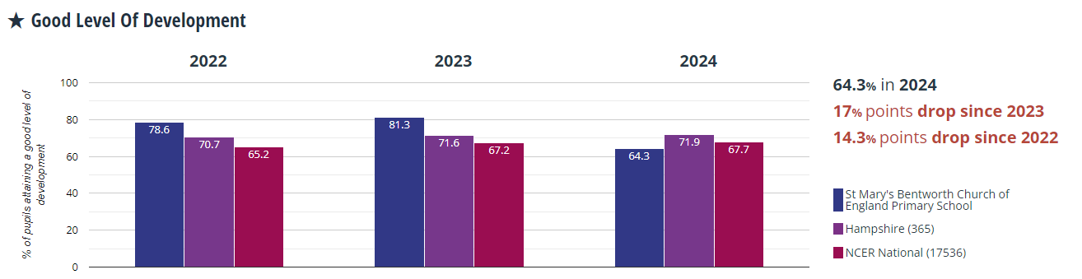
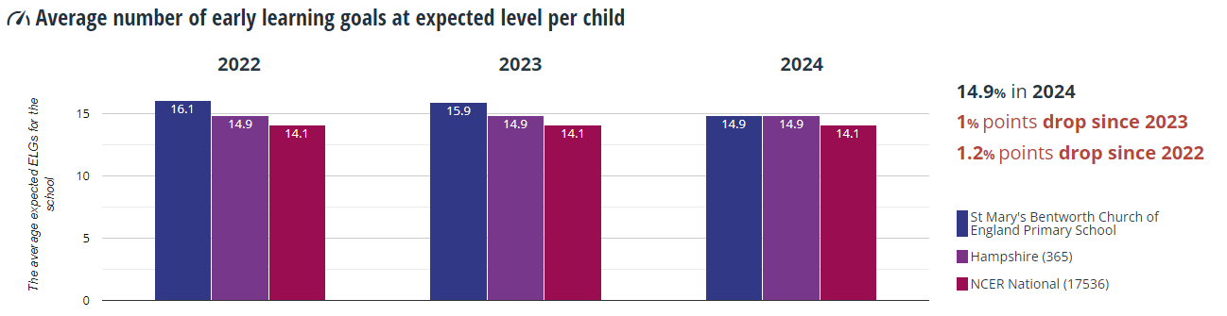
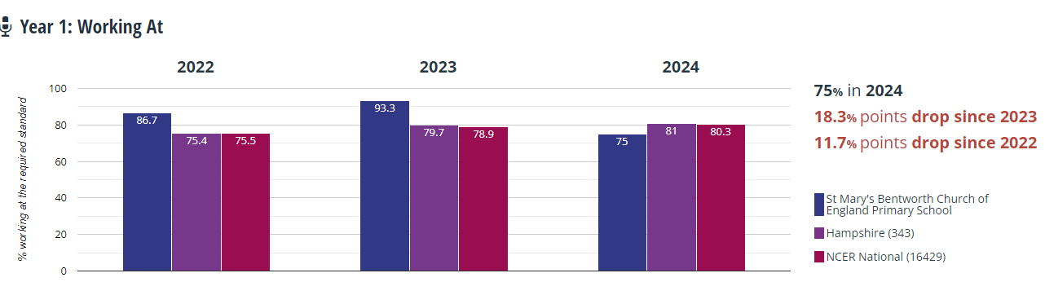
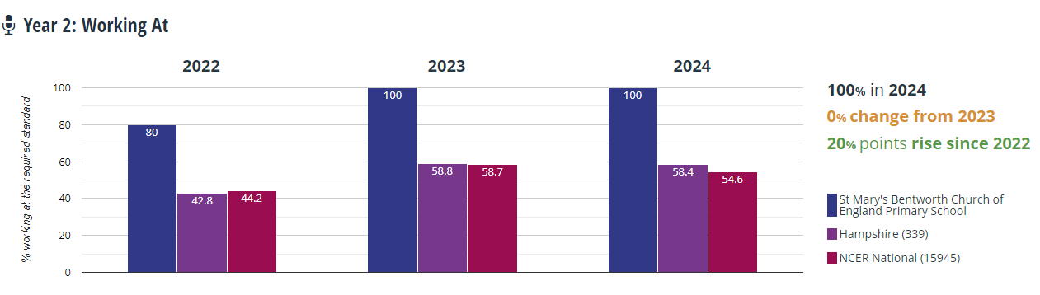

Key Stage 2: Year 6 (DfE July)


