Survive and Blossom
 | 1st half | 2nd half
Autumn | Why do we need to learn about how we survive and how we blossom?  Confidence to have a go! | Persistence  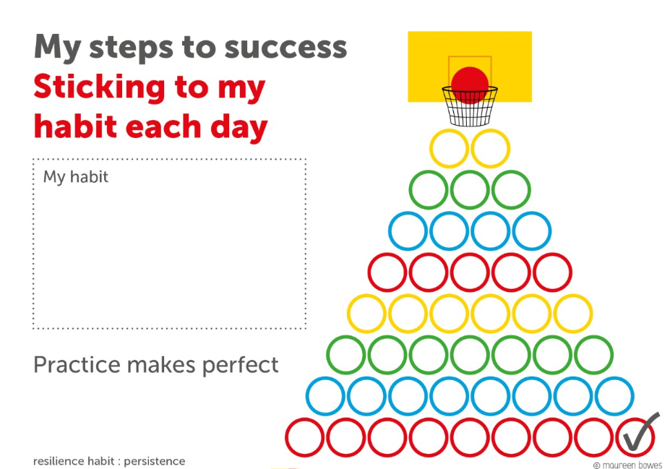
Spring | Realistic Optimism  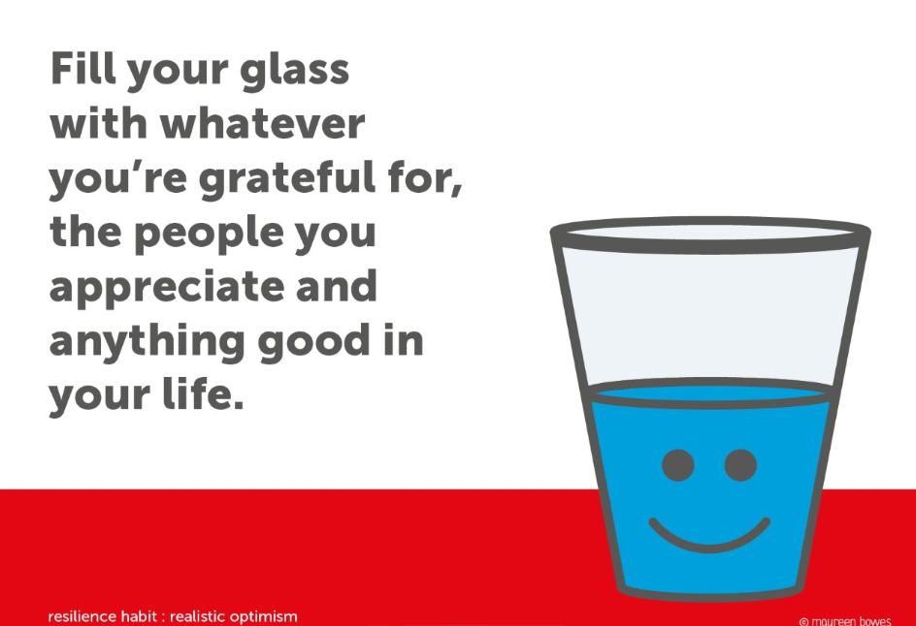 | Mutual Respect  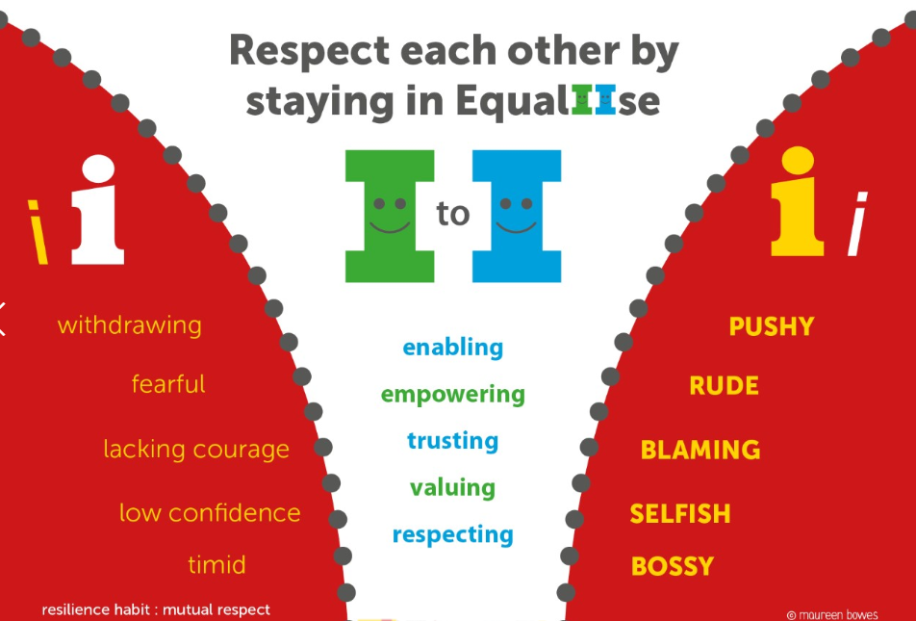
Summer | Self- care  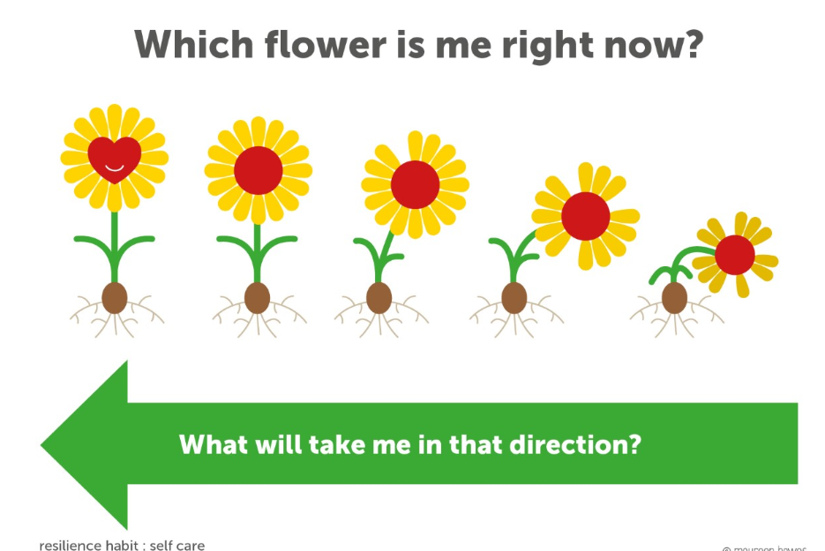 | Mental toughness  

