St Mary’s Bentworth CE Primary School- Whole school data 2025
Early Years Foundation Stage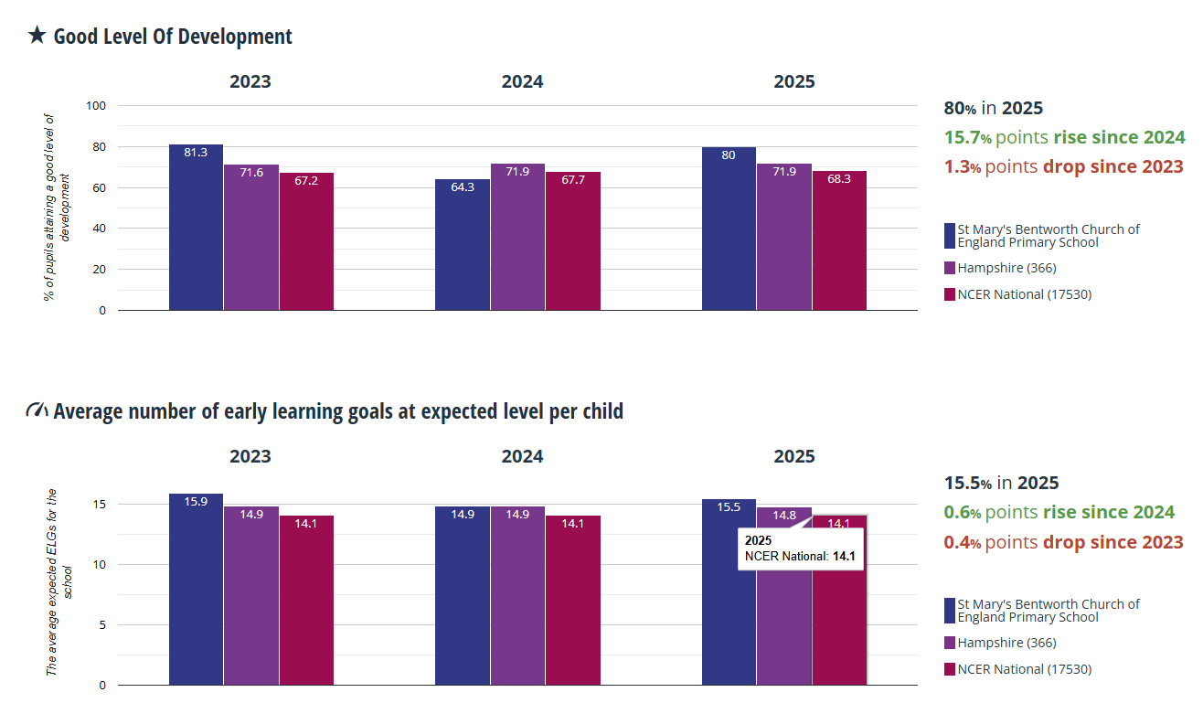

Phonics: Year 1
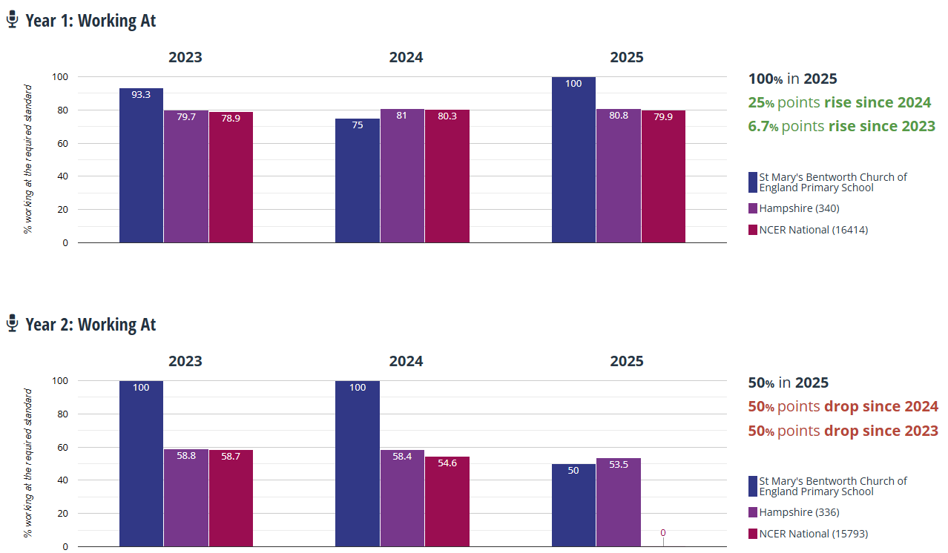

End of Key Stage 2 (Year 6)


